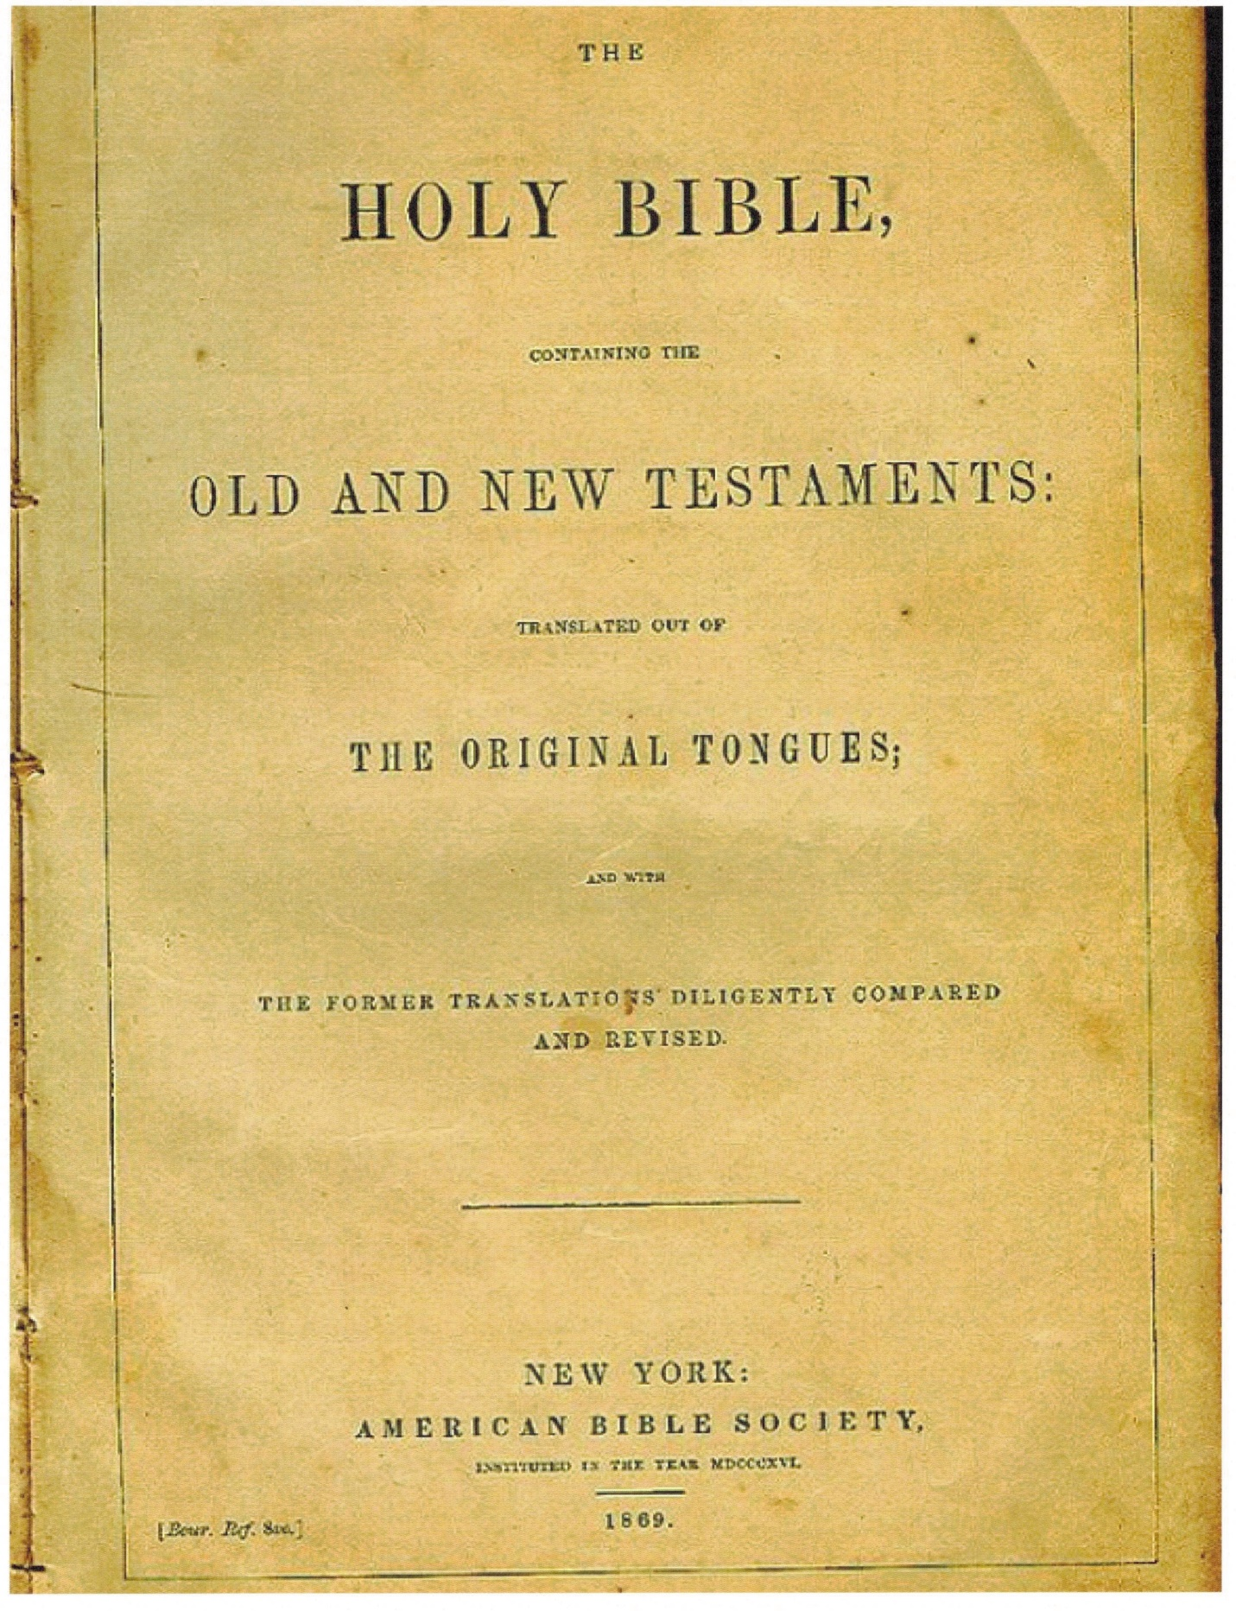
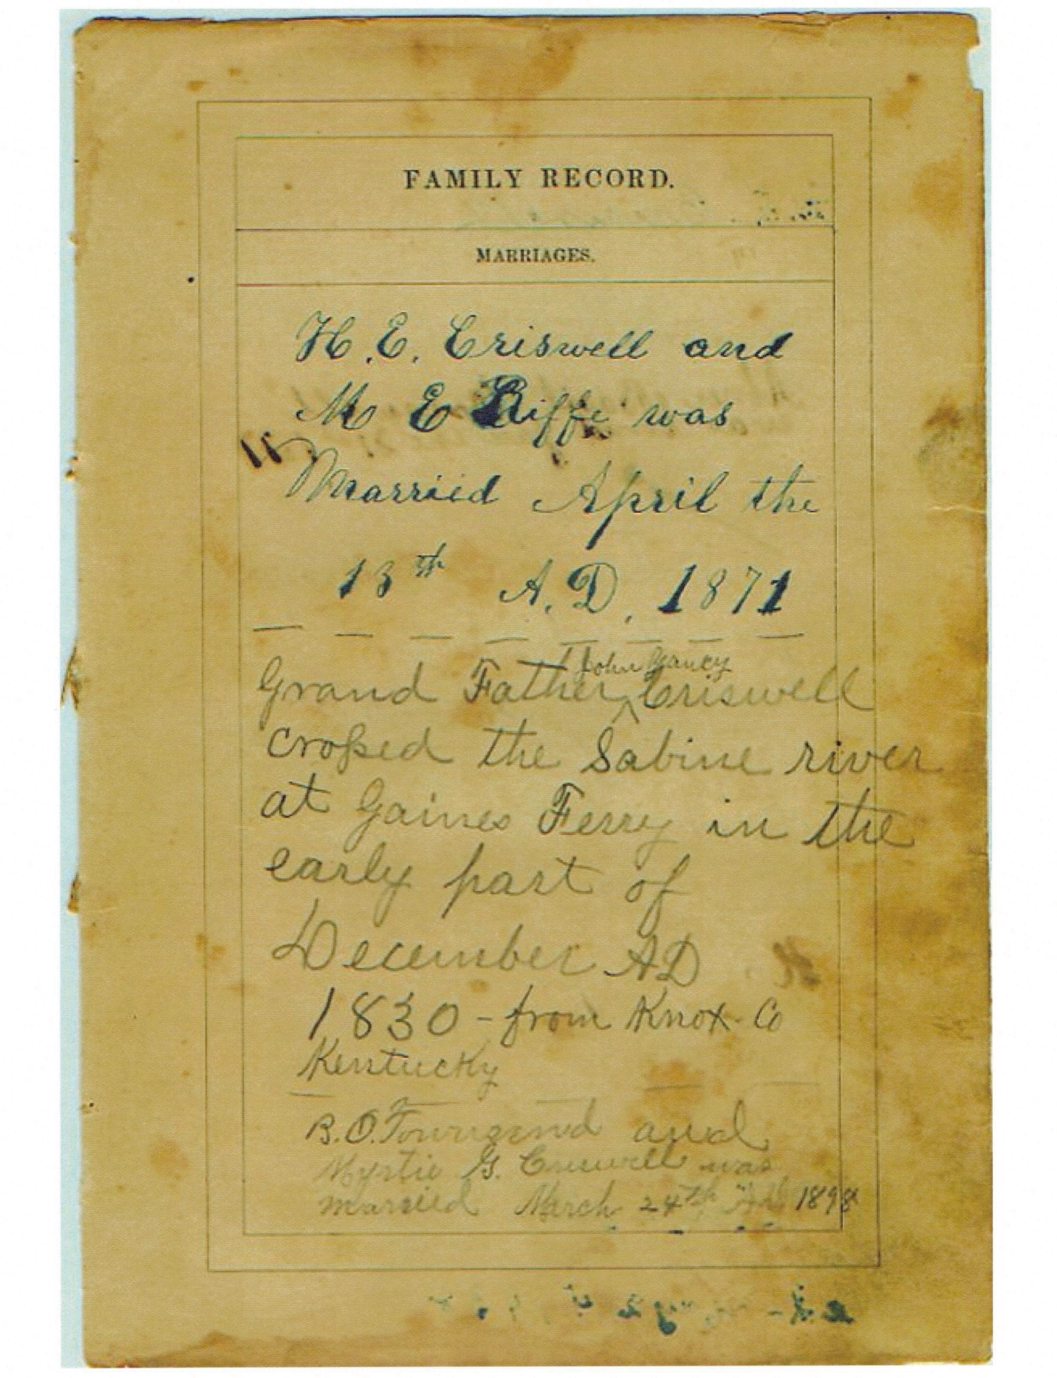

H. E. Criswell and
M. E. Riffer was
Married April the
18th A.D. 1871
Grand Father John Yancy Criswell
Crossed the Sabine river
At Gaines Ferry in the
Early part of
December AD
1840 – from Knox Co
Kentucky
B. O. Townsend and
Myrtie G. Criswell was
Married March 24th AD 1898
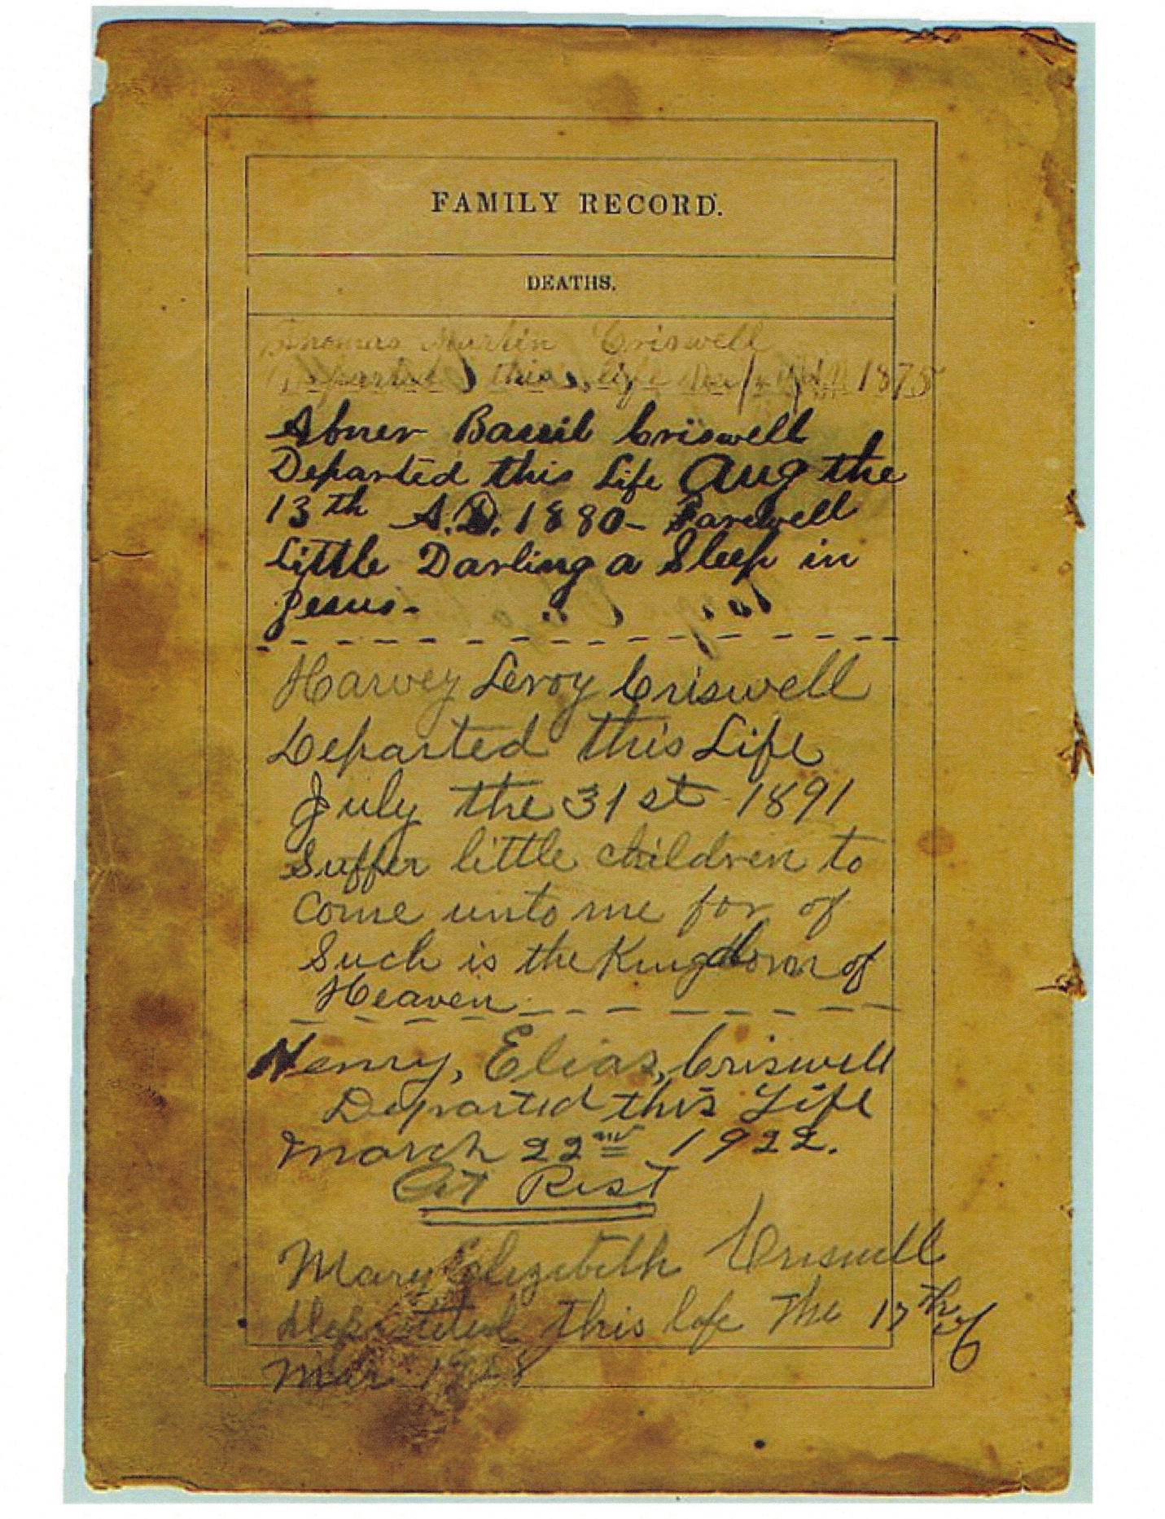

Thomas Marlin Criswell
Departed this life Dec 4 th AD 1875
Abner Basil Criswell
Departed this life Aug the
13th A.D. 1880 – Farewell
Little Darling a Sleep in Jesus
Harvey Leroy Criswell
Departed this Life
July the 31st 1891
Suffer little children to
Come unto me for of
Such is the kingdom of
Heaven
Henry Elias Criswell
Departed this Life
March 22nd 1922
Get rest
Mary Elizabeth Criswell
Departed this lif the 17th of
Mar 1928
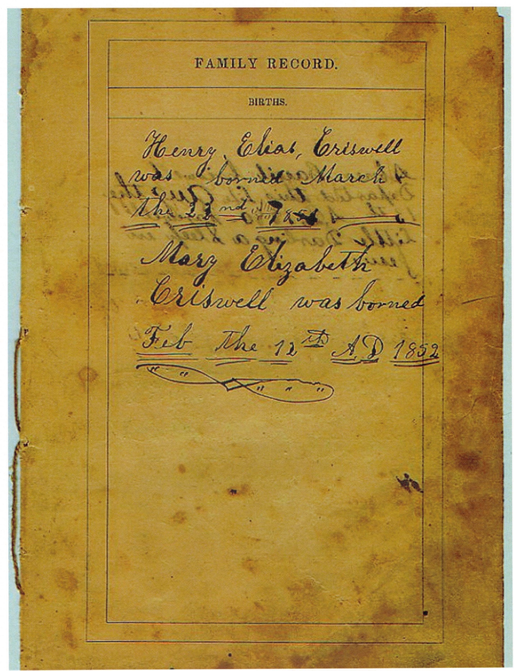

Henry Elias Criswell
Was born March
The 22nd Mar 1851
Mary Elizabeth
Criswell was born
Feb the 12th A.D. 1852
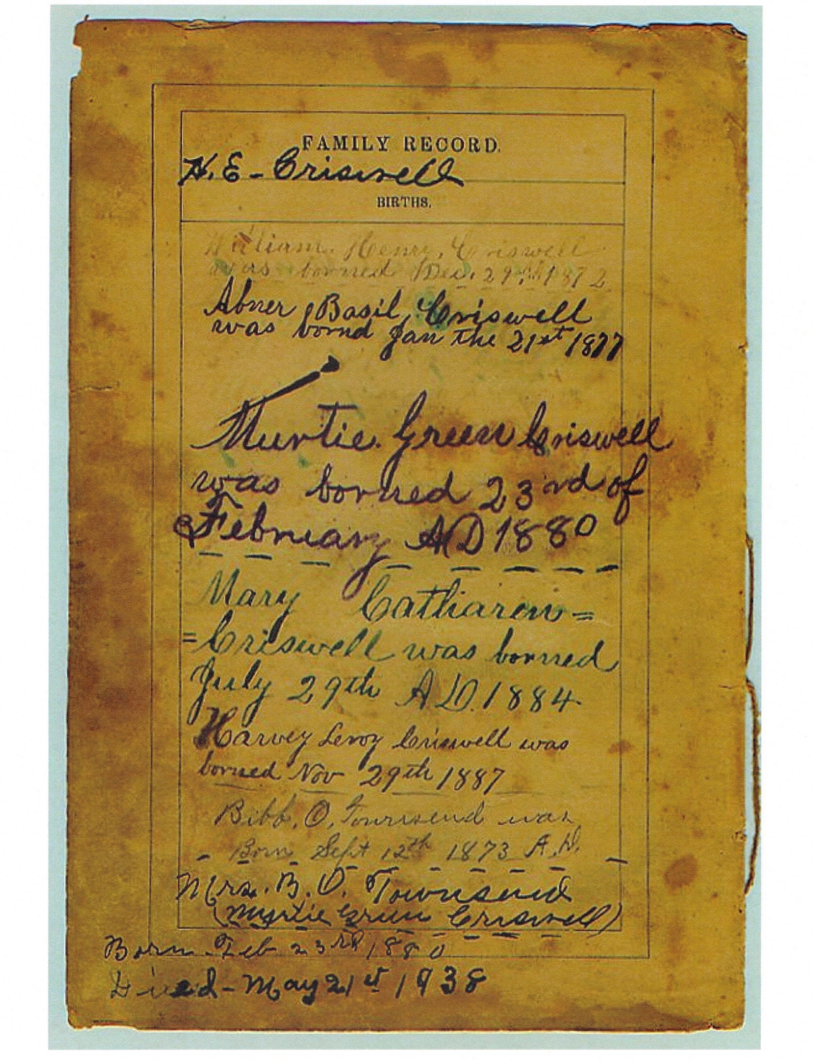

Family Record
H. E. Criswell
Births
William Henry Criswell
Was born Dec 29th 1872
Abner Basil Criswell
Was born Jan the 21st 1877
Murtie Green Criswell
Was born 23rd of
February AD 1880
Mary Catherine
Criswell was born
July 29th AD 1884
Harvey Leroy Criswell was
Borned Nov 29th 1887
Bibb O Townsend was
Born Sept 12th 1872 AD
Mrs. B. O. Townsend
Myrtie Green Criswell
Born Feb 23rd 1880
Died May 21st 1938

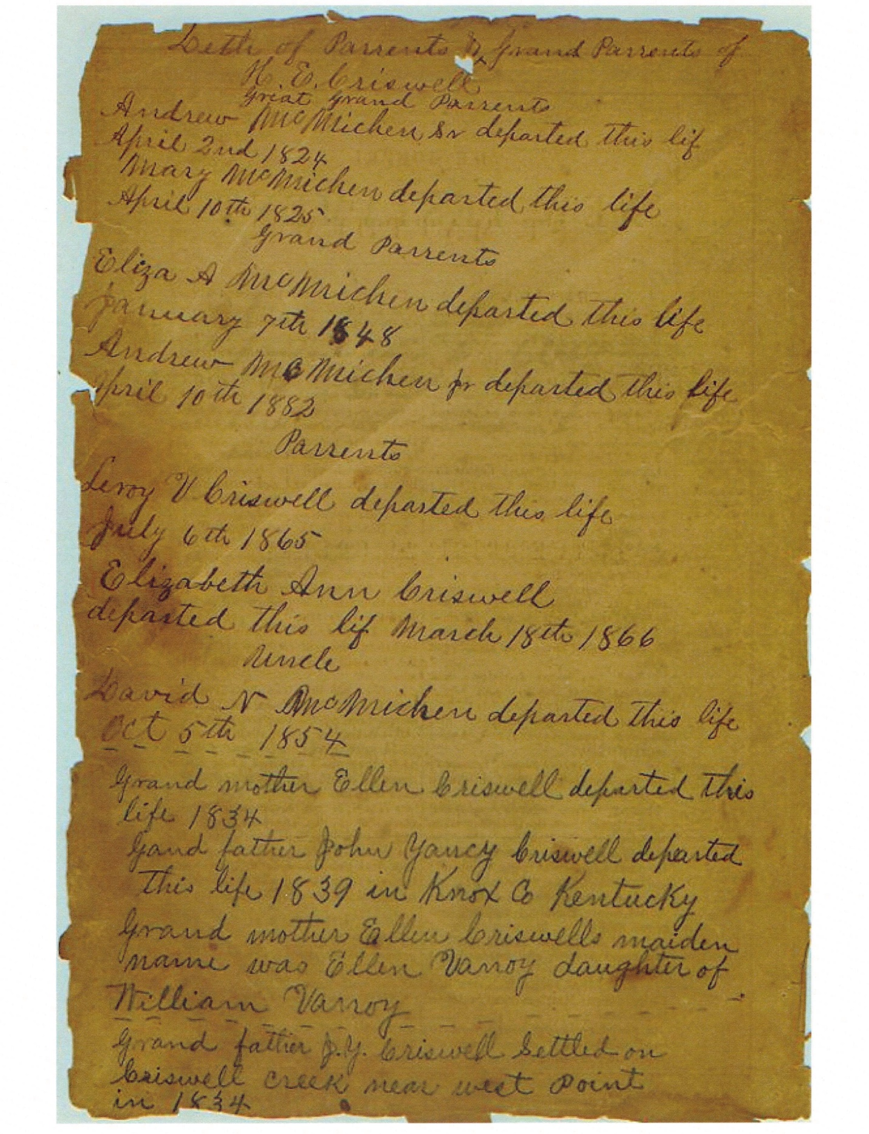

Death of parents and grandparents of
H.E. Criswell
Great Grand Parents
Andrew McMichen Sr Departed this life
April 10th 1825
Grand Parents
Eliza A McMichen departed this life
January 7th 1848
Andrew McMichen Departed this life
April 10 th 1882
Parent
Leroy V Criswell departed this life
July 6th 1865
Elizabwth Ann Criswell
Departed this lif March 18th 1866
Uncle
David V McMichen departed this life
Oct 5th 1854
Grand Mother
Ellen Criswell departed this
Life 1834
Grand father John Yancy Criswell departed this
Life 1839 in Knox Co Kentucky
Grand mother Ellen Criswells maiden
Name was Ellen Vanoy daughter of
Willaim Vanoy
Grand father J.Y. Criswell Settled on
Criswell creek near West Point
In 1834

